You only have one chance to make a good first impression to a potential client. The front lawn and garden is the doorway to the property, and unkempt grounds imply the house is not being kept up. The following packages were designed for ease of enhancing the curb appeal for homes put up for sale. The homeowner can simply choose a package that will fit within their budget. Goal: to showcase a property in the best possible way to help clients get top dollar for their property.
Curb Appeal
Enhancement Packages

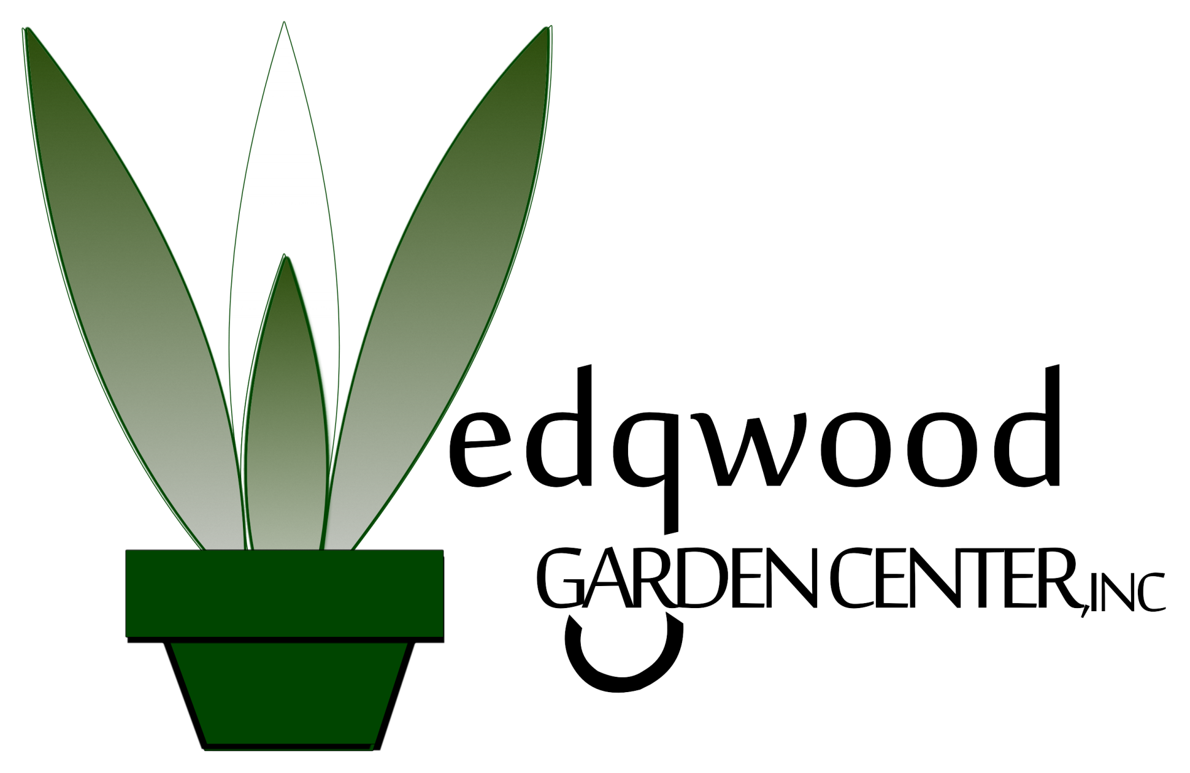

- Bronze Package
  - Removal of debris, such as branches, leaves, dead shrubs, etc.
  - Up to 8 small to medium sized shrubs trimmed or pruned
  - Cut lawn, bag grass, weed-eat and blow off pavement
  - Define bed edges with 3” deep edge
  - Remove weeds from beds, apply pre-emergent to control growth
  - 3 cubic yards of doubled-shredded, colorized, dark brown mulch
Total: $495

- Silver Package
  - 9 assorted perennials, or 5 one gallon shrubs
  - 18 assorted annuals for color enhancement, 6” pots
  - Removal of debris, such as branches, leaves, dead shrubs, etc.
  - Up to 14 small to medium sized shrubs trimmed or pruned
  - Up to 3 small trees pruned (basic pruning, mostly for enhanced visibility)
  - Cut lawn, bag grass, weed-eat and blow off pavement
  - Define bed edges with 3” deep edge
  - Remove weeds from beds, apply pre-emergent to control growth
  - 4 cubic yards of double-shredded, colorized, dark brown mulch
Total: $795

- Gold Package
  - 15 assorted perennials, or 9 one gallon shrubs
  - 25 assorted annuals for color enhancement, 6” pots
  - Removal of debris, such as branches, leaves, dead shrubs, etc.
  - Up to 22 small to medium sized shrubs trimmed or pruned
  - Up to 3 small trees pruned (basic pruning, mostly for enhanced visibility)
  - Cut lawn, bag grass, weed-eat and blow off pavement
  - Define bed edges with 3” deep edge
  - Remove weeds from beds, apply pre-emergent to control growth
  - 5 cubic yards of double-shredded, colorized, dark brown mulch
Total: $995

Prices above are for front lawn and gardens only, and based on property lot sizes up to 12,000 sq. ft. Substitutions are allowed in exchange for
other work, i.e. annuals in exchange for more mulch, etc. Contractor reserves the right to refuse service if property exceeds acceptable
conditions, or if property requires more work than can be completed under the selected package. Lawn height not to exceed 10”. Please notify
us if property is larger or requires more work than can be handled under one of the above packages. To sign up, please see agreement attached.
721-B Fishermans Rd., Norfolk, Virginia 23503 Office: (757) 587-4481 | (757) 427-3300
Jay Lane: (757) 581-7859 | Gail Dickerson: (757) 435-4372 | Mark Kontovich: (757) 291-4973
Fax: (757) 583-4173 E-mail: CurbAppeal@wedgwoodlandscaping.com Visit: www.WedgwoodLandscaping.com

