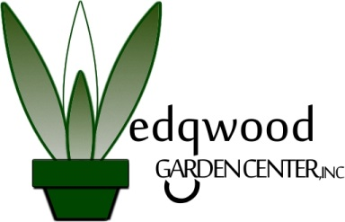

To our valued local realtors:
Our curb appeal packages are the perfect solution for home owners wishing to improve their home’s ‘first impression’ or realtors looking to give their clients a competitive edge. Wedgwood Garden Center offers the following curb appeal packages that work to showcase homes in the best possible way:
Bronze Package: $495
Silver Package: $795
Gold Package: $995
These packages may include tasks like pruning, removal of dead or compacted plantings and yard clean-up; mowing, bed definition (edging) and weeding; application of a weed prevention product and shredded hardwood mulch; adding shrubs and flowering annuals and more.
We would be happy to customize an ‘Open House’ package to showcase newly listed properties or to coincide with Open Houses.
Ready to get started? Sign the agreement and return it to our office via fax or email. We work to start jobs 5 business days after receipt of the signed agreement!
Our promise to you: we will showcase each property by improving its first impression and overall curb appeal.
